**Memo**

To: Professor Pisano

From: Ben Brewer, Ib Chand, Alex Prior, Allen Zou

Team: NoiseHub Team 8

Date: 03/18/2022

Subject: Second Prototype Test Plan

1. **Required Materials**

**Hardware:**

* Raspberry Pi 4B
* Thermistor
* Garmin LIDAR-Lite v4 x2
* Raspberry Pi Case
* Adafruit USB Microphone
* 12W USB C Power Adapter (RPI)
* Laptop (Pi SSH)
* Mobile Device (App observation)

**Software:**

* Python Scripts:
  + Lidar, mic, thermistor data sourcing and transmission
* Amazon Web Services (Backend)
  + AWS Cognito
  + AWS DynamoDB
  + AWS Amplify
  + AWS AppSync
  + AWS TimeStream
* React Native Mobile Application

**2.0 Test Setup**

The Raspberry Pi will be turned on and connected to BU’s network. Next, the team will ensure the Lidar and thermistor are properly wired. Then, the team will SSH into both Pi’s to display real-time data and observe changes in room conditions.

**3.0 Test Procedure**

1. SSH into both Pi’s on team member’s laptops
2. Run microphone script on encased Pi at team bench
3. Observe changes in noise level (low, medium, high) as team members talk closer and further away from the mic
4. Run Lidar and thermistor script on Pi at the lab door entrance
5. Observe changes in temperature as the thermistor is wrapped in a team members hand
6. Walk in and out of the door in following groupings to observe headcount change:
   1. Two people exit
   2. One person enters
   3. One person enters, one person immediately exits
   4. One person exits
   5. Two people enter
   6. Three people exit
   7. Three people enter

**4.0 Measurable Criteria**

**Lidar Results (75% Accuracy Acceptable)**

| Data set # | 0 | 1 | 2 | 3 | 4 | 5 | 6 | 7 |
| --- | --- | --- | --- | --- | --- | --- | --- | --- |
| Expected Headcount | 0 | -2 | -1 | -1 | -2 | 0 | -3 | 0 |
| Received Headcount | 0 |  |  |  |  |  |  |  |

**Thermistor Results**

| Data set # | 1 | 2 | 3* | 4 | 5 | 6 | 7 | 8 | 9 | 10 |
| --- | --- | --- | --- | --- | --- | --- | --- | --- | --- | --- |
| Thermistor Data |  |  |  |  |  |  |  |  |  |  |

*Thermistor wrapped in hand after this sample

**Microphone Results**

| Data set # | 1 | 2 | 3 | 4 | 5 | 6 | 7 | 8 | 9 | 10 |
| --- | --- | --- | --- | --- | --- | --- | --- | --- | --- | --- |
| Microphone State |  |  |  |  |  |  |  |  |  |  |

0 = Low

1 = Medium

2 = High

**5.0 Hardware Pinout**

Thermistor circuit

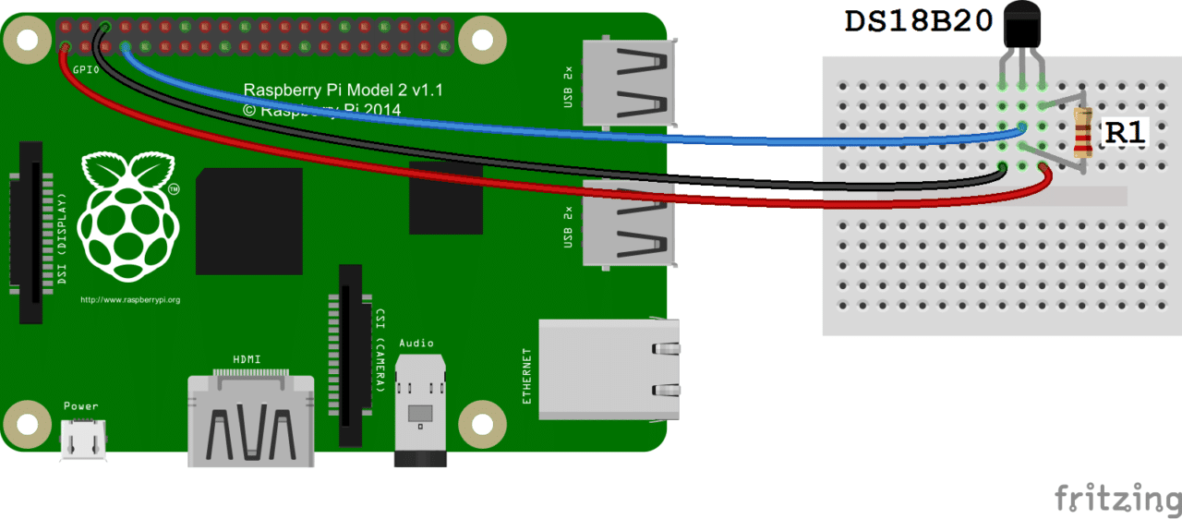

(Source: <https://www.circuitbasics.com/raspberry-pi-ds18b20-temperature-sensor-tutorial/>)

Lidar circuit

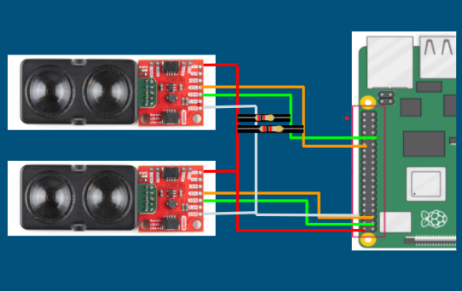

**Pinout Table**

| Raspberry Pi Pin # | Pin Description | Pin Usage |
| --- | --- | --- |
| 1 | 3.3 V | Soldered lidar |
| 32 | GPIO i2c | Soldered lidar |
| 2 | 5V | Unsoldered & therm |
| 3 | i2c | Qwiic lidar |
| 5 | i2c | Qwiic lidar |
| 7 | GPIO | Therm data |
| 39 | Ground |  |
| 33 | GPIO i2c | Soldered lidar |